12th Sunday after Pentecost

CHRIST LUTHERAN CHURCH | Lodi, California
August 20, 2023

WELCOME TO WORSHIP
Welcome to Christ Lutheran Church. We pray that your soul will be strengthened by the good news about God’s grace, love, and forgiveness given to us. If you would like to learn more about our church, please speak with our pastor or one of our members after the service.
- Bathrooms are located in the fellowship hall. A changing table is located in the women’s bathroom.
WORSHIP THEME
Jesus conquers our doubt. We cannot live in this world with a perfect trust in our Savior. But God comes, even to his doubting people, with the mighty arm of his salvation to pluck us out of doubts and fears and deliver us.

The Service of the Word and Sacrament
The high and holy worship of God is faith in Jesus Christ. Such faith is created and sustained by God’s service to us (the German, “Gottesdienst,” “God/Divine Service). In the Divine Service, the Lord comes to us in His Word and Sacrament to bless and enliven us with His gifts. The Service is not something we do for God, but His service to us received in faith. The liturgy is God’s work. He gives, we receive.
HYMN By Grace I’m Saved| CW 384

INVOCATION
M: The grace of our Lord ✙ Jesus Christ and the love of God and the fellowship of the Holy Spirit be with you.
C: And also with you.

CONFESSION
From God’s Word we know that wherever God puts His name, there He is to bless. In the Old Testament the temple was the place where God graciously caused His name to be present (1 Kings 8:27-30).
God has put His name —Father, Son, and Holy Spirit—on us in Holy Baptism. The Divine Service begins with the Invocation, the words spoken over us at our baptisms. Every Divine Service is for the hallowing of the Lord’s name, which the Small Catechism reminds us is done “when the Word of God is taught in its truth and purity, and we, as the children of God, also lead holy lives according to it” (Matthew 28:18-20).
M: God invites us to come into his presence and worship him with humble and penitent hearts. Therefore, let us acknowledge our sinfulness and ask him to forgive us.
C: Holy and merciful Father, I confess that I am by nature sinful, and that I have disobeyed you in my thoughts, words, and actions. I have done what is evil and failed to do what is good. For this I deserve your punishment both now and in eternity. But I am truly sorry for my sins, and trusting in my Savior
Jesus Christ, I pray: Lord, have mercy on me, a sinner.

absolution
M: God, our heavenly Father, has been merciful to us and has given his only Son to be the atoning sacrifice for our sins. Therefore, as a
called servant of Christ and by his authority, I forgive you all your
sins in the name of the Father and of the Son ✙ and of the Holy Spirit.
C: Amen
LORD, HAVE MERCY - Kyrie
M: For all that we need in life and for the wisdom to use all your gifts with gratitude and joy, hear our prayer, O Lord.
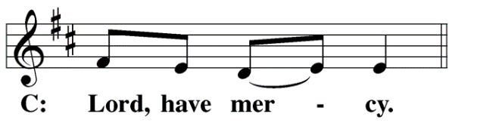
M: For the steadfast assurance that nothing can separate us from your love and for the courage to stand firm against the assaults of Satan and every evil, hear our prayer, O Christ.
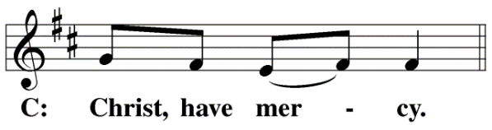

M: For the well-being of your holy Church in all the world and for those who offer here their worship and praise, hear our prayer, O Lord.
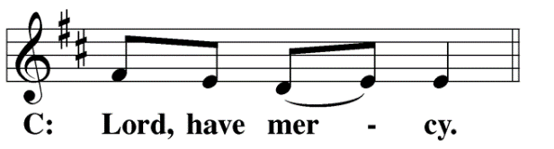
M: Merciful God, maker and preserver of life, uphold us by your power and keep us in your tender care:
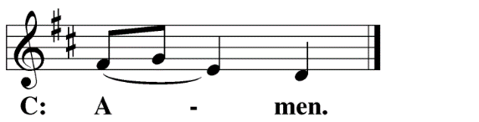
M: The works of the Lord are great and glorious; his name is worthy of praise.

O LORD, OUR LORD
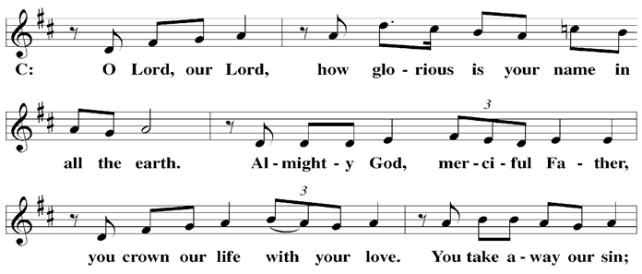

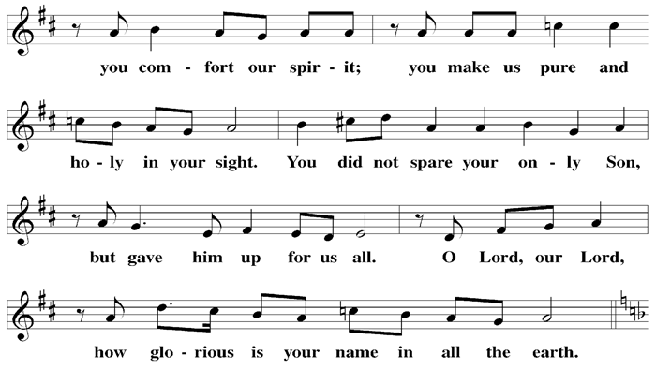

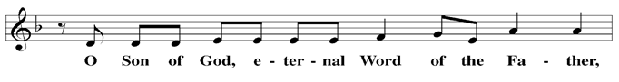

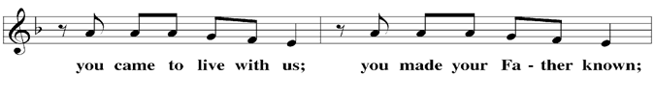

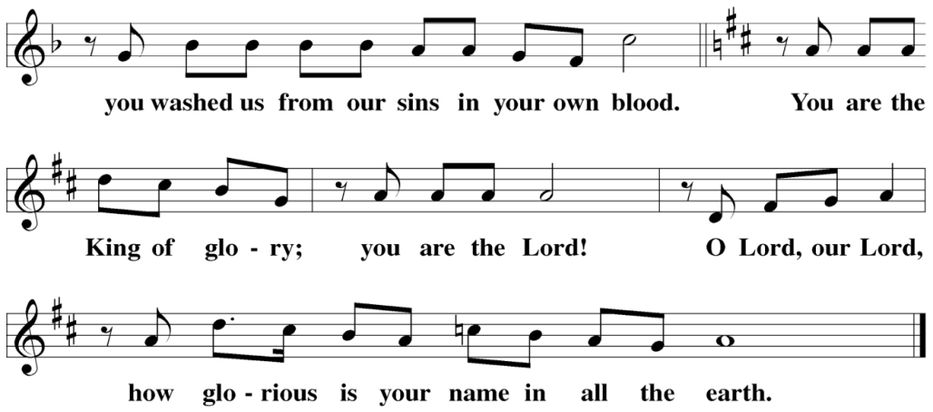

The Service of the Word
Having just received absolution for their sins, believers now gather around the Word of God to find encouragement and peace for their lives on earth.
PRAYER OF THE DAY
M: Let us pray.
Almighty and everlasting God, you are always more ready to hear than we to pray, and to give more than we either desire or deserve. Pour upon us the abundance of your mercy, forgiving us those things of which our conscience is afraid, and giving us those good things for which we are not worthy to ask, except through the merits and mediation of your Son, Jesus Christ our Lord, who lives and reigns with you and the Holy Spirit, one God, now and forever.
C: Amen
FIRST LESSON Exodus 14:10–31
Moses leads the Israelites on dry ground across the Red Sea, while the armies of Pharaoh are drowned behind them. Though the Israelites doubted, God delivered them.
¹⁰ As Pharaoh approached, the Israelites looked up, and there were the Egyptians, marching after them. They were terrified and cried out to the Lord. ¹¹ They said to Moses, “Was it because there were no graves in Egypt that you brought us to the desert to die? What have you done to us by bringing us out of Egypt? ¹² Didn’t we say to you in Egypt, ‘Leave us alone; let us serve the Egyptians’? It would have been better for us to serve the Egyptians than to die in the desert!”
¹³ Moses answered the people, “Do not be afraid. Stand firm and you will see the deliverance the Lord will bring you today. The Egyptians you see today you will never see again. ¹⁴ The Lord will fight for you; you need only to be still.”
¹⁵ Then the Lord said to Moses, “Why are you crying out to me? Tell the Israelites to move on. ¹⁶ Raise your staff and stretch out your hand over the sea to divide the water so that the Israelites can go through the sea on dry ground. ¹⁷ I will harden the hearts of the Egyptians so that they will go in after them. And I will gain glory through Pharaoh and all his army, through his chariots and his horsemen. ¹⁸ The Egyptians will know that I am the Lord when I gain glory through Pharaoh, his chariots and his horsemen.”

¹⁹ Then the angel of God, who had been traveling in front of Israel’s army, withdrew and went behind them. The pillar of cloud also moved from in front and stood behind them, ²⁰ coming between the armies of Egypt and Israel. Throughout the night the cloud brought darkness to the one side and light to the other side; so neither went near the other all night long.
²¹ Then Moses stretched out his hand over the sea, and all that night the Lord drove the sea back with a strong east wind and turned it into dry land. The waters were divided, ²² and the Israelites went through the sea on dry ground, with a wall of water on their right and on their left.
²³ The Egyptians pursued them, and all Pharaoh’s horses and chariots and horsemen followed them into the sea. ²⁴ During the last watch of the night the Lord looked down from the pillar of fire and cloud at the Egyptian army and threw it into confusion. ²⁵ He jammed the wheels of their chariots so that they had difficulty driving. And the Egyptians said, “Let’s get away from the Israelites! The Lord is fighting for them against Egypt.”
²⁶ Then the Lord said to Moses, “Stretch out your hand over the sea so that the waters may flow back over the Egyptians and their chariots and horsemen.” ²⁷ Moses stretched out his hand over the sea, and at daybreak the sea went back to its place. The Egyptians were fleeing toward it, and the Lord swept them into the sea. ²⁸ The water flowed back and covered the chariots and horsemen—the entire army of Pharaoh that had followed the Israelites into the sea. Not one of them survived.
²⁹ But the Israelites went through the sea on dry ground, with a wall of water on their right and on their left. ³⁰ That day the Lord saved Israel from the hands of the Egyptians, and Israel saw the Egyptians lying dead on the shore. ³¹ And when the Israelites saw the mighty hand of the Lord displayed against the Egyptians, the people feared the Lord and put their trust in him and in Moses his servant.
PSALM Psalm 73, pg. 94
SECOND LESSON James 1:2–12
In what do we trust? If we trust God, we can be sure that he will provide us with all we need. If we trust in the things of this world, we should expect their power to wither and fade.
² Consider it pure joy, my brothers and sisters, whenever you face trials of many kinds, ³ because you know that the testing of your faith produces perseverance. ⁴ Let perseverance finish its work so that you may be mature and complete, not lacking anything.

⁵ If any of you lacks wisdom, you should ask God, who gives generously to all without finding fault, and it will be given to you. ⁶ But when you ask, you must believe and not doubt, because the one who doubts is like a wave of the sea, blown and tossed by the wind. ⁷ That person should not expect to receive anything from the Lord. ⁸ Such a person is double-minded and unstable in all they do.
⁹ Believers in humble circumstances ought to take pride in their high position. ¹⁰ But the rich should take pride in their humiliation—since they will pass away like a wild flower. ¹¹ For the sun rises with scorching heat and withers the plant; its blossom falls and its beauty is destroyed. In the same way, the rich will fade away even while they go about their business.
¹² Blessed is the one who perseveres under trial because, having stood the test, that person will receive the crown of life that the Lord has promised to those who love him.
VERSE OF THE DAY Hebrews 11:1
Alleluia. Now faith is being sure of what we hope for and certain of what we do not see. Alleluia.
THE GOSPEL Matthew 14:22–33
Jesus walks on the water and Peter joins him. Though Peter’s doubts threaten, Jesus delivers him.
²² Immediately Jesus made the disciples get into the boat and go on ahead of him to the other side, while he dismissed the crowd. ²³ After he had dismissed them, he went up on a mountainside by himself to pray. Later that night, he was there alone, ²⁴ and the boat was already a considerable distance from land, buffeted by the waves because the wind was against it.
²⁵ Shortly before dawn Jesus went out to them, walking on the lake. ²⁶ When the disciples saw him walking on the lake, they were terrified. “It’s a ghost,” they said, and cried out in fear.
²⁷ But Jesus immediately said to them: “Take courage! It is I. Don’t be afraid.”
²⁸ “Lord, if it’s you,” Peter replied, “tell me to come to you on the water.”
²⁹ “Come,” he said.
Then Peter got down out of the boat, walked on the water and came toward Jesus. ³⁰ But when he saw the wind, he was afraid and, beginning to sink, cried out, “Lord, save me!”
³¹ Immediately Jesus reached out his hand and caught him. “You of little faith,” he said, “why did you doubt?”
³² And when they climbed into the boat, the wind died down. ³³ Then those who were in the boat worshiped him, saying, “Truly you are the Son of God.”

M This is the Gospel of the Lord.
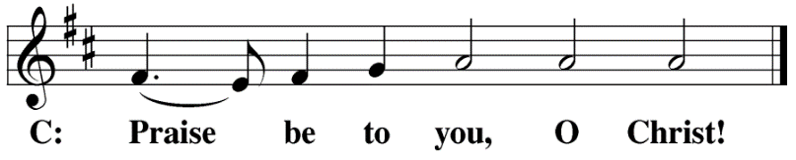

HYMN OF THE DAY Be Still, My Soul| CW 415
SERMON Matthew 14
NICENE CREED
Having heard the Word of God, we confess our faith in His name. The creed is our saying back to God what He has first said to us. In the Creed we acclaim the truth of the triune God and His work of salvation accomplished for us in His incarnate Son, Jesus Christ.
We believe in one God, Dt. 6:4
The Nicene Creed is the great Confession of the Christian faith professed by all Christians. The Creed originated at the First Council of Nicaea (c. AD. 325)
the Father, the Almighty, 2 Cor. 6:18
maker of heaven and earth, Is. 51:13
of all that is, seen and unseen. Col. 1:16
We believe in one Lord, Jesus Christ, 1 Cor 8:6
the only Son of God, Jn. 3:16
eternally begotten of the Father, Heb. 1:2,5
God from God, Light from Light, true God from true God, Jn. 1
begotten, not made, of one being with the Father. Jn. 10:30
Through him all things were made. Jn. 1:3
For us and for our salvation, 1 Th. 5:9
The Creed itself was crafted as a confession of Scripture in opposition to the Arian heresy, which denied that the Lord Jesus and the Holy Spirit are God.

he came down from heaven, Jn. 6:38
was incarnate of the Holy Spirit and the virgin Mary, Lk. 1:35
and became fully human. Gal. 4:4
For our sake he was crucified under Pontius Pilate. Mk. 15:15
He suffered death and was buried. 1 Cor. 15:3-4a
On the third day he rose again in accordance
with the Scriptures. 1 Cor. 15:4b
He ascended into heaven Ac. 2:33-34
and is seated at the right hand of the Father. Heb. 1:13
He will come again in glory Mt. 25:31
to judge the living and the dead, 2 Tim. 4:1
and his kingdom will have no end. Lk. 1:33
We believe in the Holy Spirit, the Lord, the giver of life, Job 33:4
who proceeds from the Father and the Son, Jn. 15:26
who in unity with the Father and the Son Jn. 4:24
is worshiped and glorified,
who has spoken through the prophets. 2 Pet. 1:25
We believe in one holy Christian Mt. 16:18; Eph. 2:19-20
and apostolic Church.
We acknowledge one baptism for the forgiveness of sins. Eph. 4:5; Ac. 2:38
We look for the resurrection of the dead 1 Cor. 15:21-22
and the life of the world to come. Amen. Rev. 22

OFFERING
In response to God’s love and forgiveness, we give back a portion of what he has given us. The members of Christ Lutheran Church have joined to proclaim the gospel to this community. These offerings support that work. While our guests are welcome to participate, they should not feel obligated to do so.
PRAYER OF THE CHURCH
M: Almighty God, you have tamed the treacherous sea and guided Noah and his family across the waters. You brought your people through the Red Sea on dry ground and provided sure footing to Peter over the waves. Assure us with the promises you give your people: “When you pass through the waters, I will be with you;
C: And when you pass through the rivers, they will not sweep over you.” (Isaiah 43:2)
M: Though you call us to go through trial and difficulty. Though our loved ones must carry the cross. Though we face the temptations of the devil and the assaults of the sinful world,
C: You are faithful, you will not let us be tempted beyond what we can bear. (1 Cor. 10:13)
M: Be with all whose faith is weak. Heal those who are sick or injured. Restore the spirits of the downtrodden.
Special intercessions may follow
May all of us cling firmly to your Word, which can never be broken:
C: For nothing will be able to separate us from your love (Romans 8:39)

M: Strengthen your Church. May we bring the message of salvation to all those oppressed by sin, death, and devil’s power. Give us hands that are eager to reach out to the downtrodden. Make us bold in the battle against sin and all its effects.
C: For you have built your church, and the gates of hell cannot overcome it. (Matthew 16:18)
M: Hear us as we bring before your throne our personal doubts and fears:
Silent Prayer
M: Make us bold in our faith and our requests, and grant us courage to follow where you lead; through Jesus Christ our Lord, who taught us to pray:

LORD’S PRAYER Matthew 6:9-13; Luke 11:2-4
C: Our Father, who art in heaven, hallowed be thy name,
thy kingdom come, thy will be done on earth as it is in heaven.
Give us this day our daily bread; and forgive us our trespasses,
as we forgive those who trespass against us;
and lead us not into temptation, but deliver us from evil.
For thine is the kingdom and the power and the glory
forever and ever. Amen.

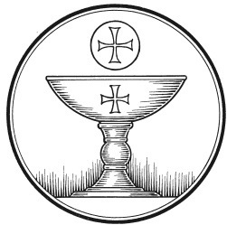
The Service of the Sacrament
This greeting marks a new service, so to speak. These ancient introductory words & phrases help to highlight, celebrate and bring attention to the Sacrament.
M: The Lord be with you.
C: And also with you.
M: Lift up your hearts.
C: We lift them up to the Lord.
M: Let us give thanks to the Lord our God.
C: It is right to give him thanks and praise.
M: Praise to the God and Father of our Lord Jesus Christ! In love he has blessed us with every spiritual blessing. He sends the Holy Spirit to testify that we are his children and to strengthen us when we are weak. Now have come the salvation and the power and the kingdom of our God and the authority of his Christ. To him who sits on the throne and to the Lamb be praise and thanks and honor and glory for ever and ever:
HOLY, HOLY, HOLY – Sanctus
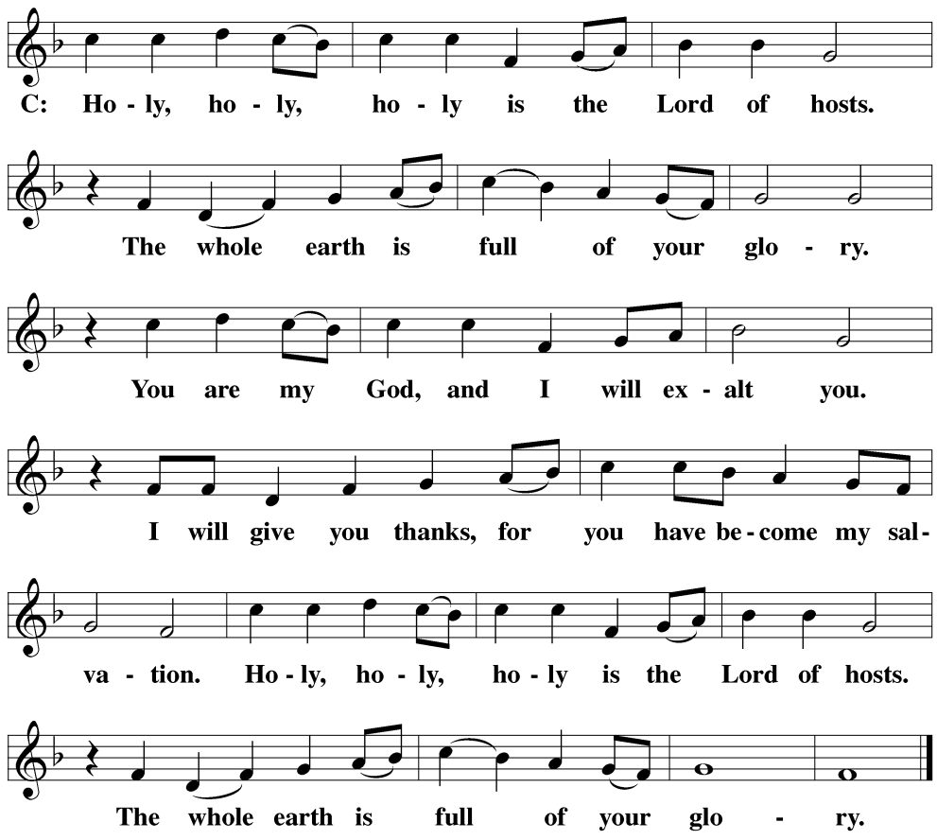
WORDS OF INSTITUTION Matthew 26, Mark 14, Luke 22
M: Our Lord Jesus Christ, on the night he was betrayed, took bread; and when he had given thanks, he broke it and gave it to his disciples, saying: “Take and eat. This is my ✙ body, which is given for you. Do this in remembrance of me.”
The Words of institution both proclaim the words of Jesus to the congregation and sets apart the bread and wine for the Lord’s Supper.
Then he took the cup, gave thanks, and gave it to them, saying, “Drink from it all of you; this is my ✙ blood of the new covenant, which is poured out for you for the forgiveness of sins. Do this, whenever you drink it, in remembrance of me.”
PEACE OF THE LORD – Pax Domini John 20:19
M: The peace of the Lord be with you always.
C: Amen

O CHRIST, LAMB OF GOD – Agnus Dei John 1:29
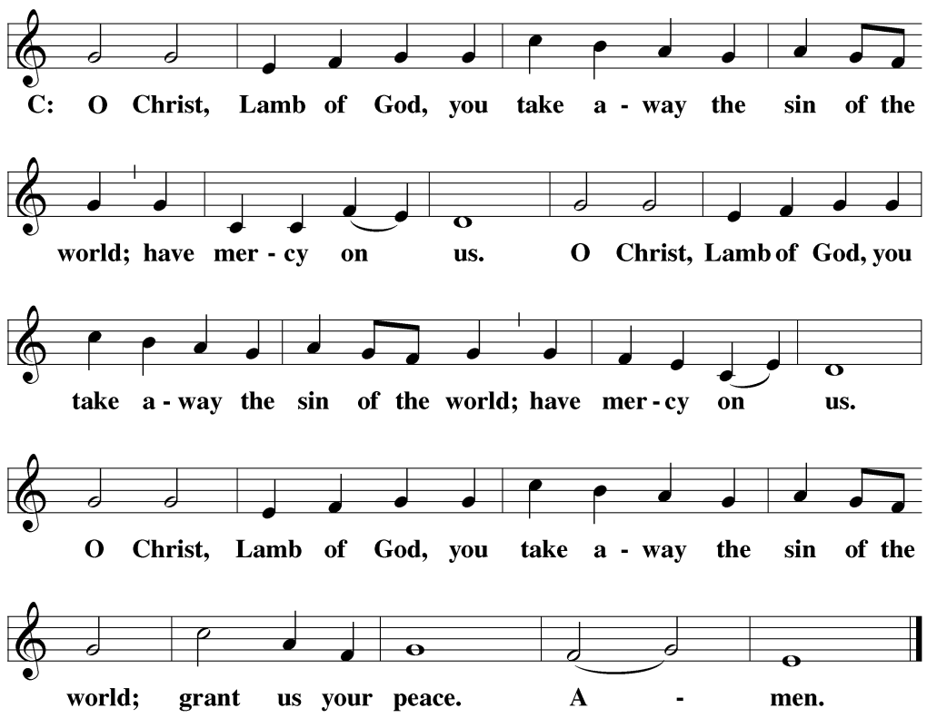
DISTRIBUTION
Those who will be receiving Holy Communion today may wish to read Personal Preparation for Holy Communion, found on page 156 in the front section of the hymnal. This page helps us put into practice what the Bible encourages: “Everyone ought to examine themselves before they eat of the bread and drink from the cup.” (1 Corinthians 11:28)
Christ Lutheran Church confesses and practices the Biblical teaching of a Closed Communion. We ask that only members of the Wisconsin Synod [WELS] or the Evangelical Lutheran Synod [ELS] join us at the Lord’s Table. If you have questions concerning our communion practice, or would like to inquire about how you, too, can commune with us, please speak with the Pastor following the service.

THANK THE LORD
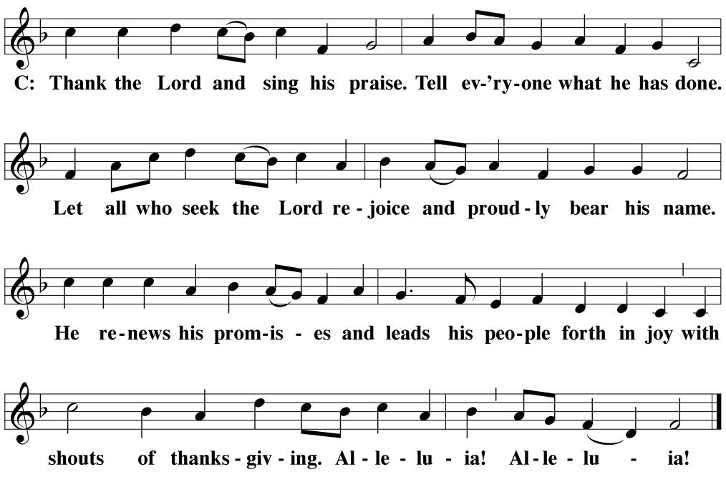
M: Hear the prayer of your people, O Lord, that the lips which have praised you here may glorify you in the world, that the eyes which have seen the coming of your Son may long for his coming again, and that all who have received in his true body and blood the pledge of your forgiveness may be restored to live a new and holy life, through Jesus Christ, our Lord, who lives and reigns with you and the Holy Spirit, one God, now and forever.
C: Amen.

THE BLESSING
M: Brothers and sisters, go in peace. Live in harmony with one another. Serve the Lord with gladness.
The Lord bless you and keep you.
The Lord make his face shine on you and be gracious to you.
The Lord look on you with favor and ✙ give you peace.
C: Amen.

CLOSING HYMN How Firm a Foundation | CW 416

COPYRIGHT INFORMATION
Content requiring a copyright license is reproduced under OneLicense.net #A-718312. All rights reserved. The Common Service: Texts revised from The Lutheran Hymnal, 1941. Music revised by James Engel. Scripture Quotations: From the Holy Bible, New International Version (NIV 1984), © 1973, 1978, 1984 by Biblica, Inc.

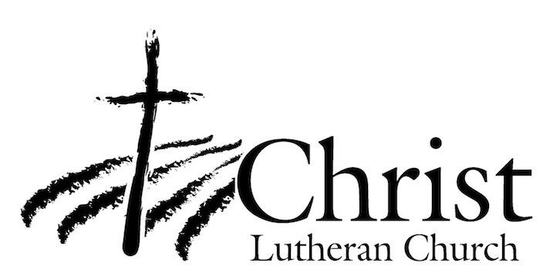
13009 N. Elderberry Ct.
Lodi, CA 95242
www.christlodi.org
209-368-6250
Pastor Tim Leistekow
WELCOME TO CHRIST EV. LUTHERAN CHURCH!
We preach a message of forgiveness, hope and peace
through the death and resurrection of Jesus Christ.
Families and individuals of all ages will find opportunities
both to grow and to serve.
Our mission statement:
Look what Christ is doing!
He binds us together in fellowship
He gathers us in for worship
He builds us up for service
He sends us out with the gospel

“Now you are the body of Christ,
and each one of you is a part of it.”
(1 Corinthians 12:27)

